Ans 1 - here are some examples of functions available in the different drop-downs in the function library:

Recently Used:

SUM: Adds up a range of numbers.

AVERAGE: Calculates the average of a range of numbers.

MAX: Returns the highest value in a range of numbers.

MIN: Returns the lowest value in a range of numbers.

AutoSum:

SUM: Adds up a range of numbers.

AVERAGE: Calculates the average of a range of numbers.

COUNT: Counts the number of cells in a range that contain numbers.

MAX: Returns the highest value in a range of numbers.

Text:

CONCATENATE: Joins two or more strings of text together.

LEFT: Returns a specified number of characters from the beginning of a text string.

RIGHT: Returns a specified number of characters from the end of a text string.

FIND: Finds the position of a string of text within another string of text.

Date & Time:

TODAY: Returns the current date.

NOW: Returns the current date and time.

YEAR: Returns the year of a given date.

MONTH: Returns the month of a given date.

These are just a few examples of the functions available in the different drop-downs in the function library. There are many more functions available for various purposes, such as financial calculations, statistical analysis, and more.

Ans 2 – There are many different ways by which we can select a row or a column in an excel sheet:

For column;

* Select a cell of any particular column which you want to select, then Press CTRL + Space key in a quick session in order to select that whole column. For example – if you select cell A1 and press CTRL + Space key then whole column A will get selected.
* We can also select any column just by clicking the top edge of the Column header

For Rows;

* Select a cell of any Row which you want to select, then Press SHIFT + Space key in a quick session in order to select that whole Row. For example – if you select cell A1 and press SHIFT + Space key then whole ROW 1 will get selected.
* We can also select any column just by clicking the Left Border of any Table Row.

Ans 3 – AutoFit is Command by using which excel automatically changes the width and height of the column and row according to the data available/content present in it to its best Fit. In order to use AutoFit there are different ways to do that mentioned as below;

* First select the whole table/or column for which you want to change the Column width, then double click on the right border of the column and it will automatically change the width to its best fit.
* Got to HOME tab > Format options > select the Auto fit Row height or AutoFit Column width option.

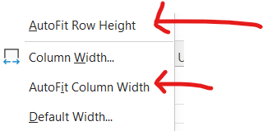

* Keyboard shortcuts – autofit row height ALT + H + O + A. for Column ALT + H + O + I.

Ans 4 – To insert a Row/ column, select a cell for which you want add a new Row (above or below)/ Column (Left or right) go to HOME tab> Insert > click on the drop down and select the desired option from the below option.

Ans 5 – select any Row number/ Column Name and it will select the whole row/column in that table then right click anywhere in that particular row/column which you have selected it will give an option to HIDE that row/column.

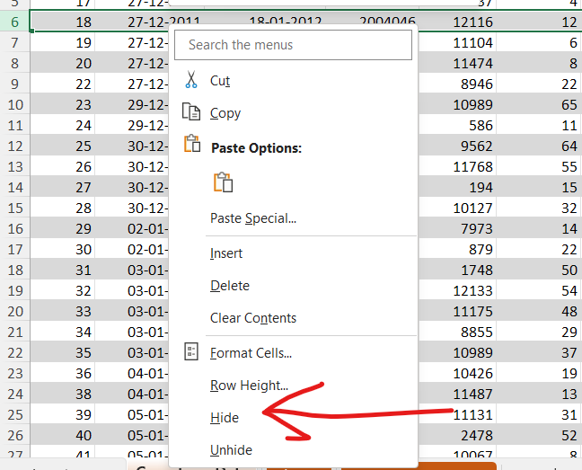

Ans 6 – refer to excel sheet

1. Autosum of sales column
2. Average Unit Price
3. Maximum Discount on a product
4. Minimum Shipping Cost
5. Total Distinct Customer

Link - [fsd-ineuron/excel assgnmnt 7.xlsx at main · sanmeet23/fsd-ineuron (github.com)](https://github.com/sanmeet23/fsd-ineuron/blob/main/excel/excel%20assgnmnt%207.xlsx)